Ex.no:6c | DATA VISUALIZATION USING POWER BI  (FOOD WASTE PREDICTION)

Aim:
To clean, preprocess, and transform the California Housing Dataset, load the cleaned data into Power BI, and build an interactive visual dashboard to analyze housing values, income, rooms, population, and ocean-proximity patterns.

Algorithm:
- Import Dataset: Load the California Housing Dataset into Power BI.
- Deduplication: Identify and remove duplicate rows from the dataset.
- Remove Blank Rows: Identify and remove completely blank records.
- Handle Missing Values: Identify missing values and handle them appropriately to maintain data consistency.
- Handle Data Type Errors: Convert numerical attributes such as total_rooms, total_bedrooms, population, households, median_income, and median_house_value into appropriate numerical data types.
- Clean Text Data: Remove unnecessary spaces and standardize the ocean_proximity categorical values.
- Load Clean Data: Load the cleaned California Housing Dataset into Power BI Desktop using Get Data → Text/CSV.
- Create Core Metrics: Create measures such as total houses, average house value, minimum house value, and maximum house value.
- Create Dashboard: Build interactive visualizations such as KPI cards, bar charts, column charts, donut charts, line charts, clustered column charts, and slicers to analyze housing patterns.

Output:
1.BAR CHART
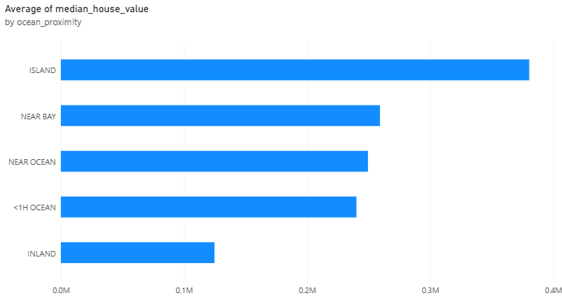

2.Column Chart
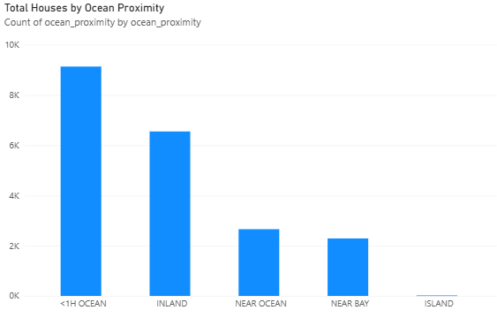

3.Donut Chart
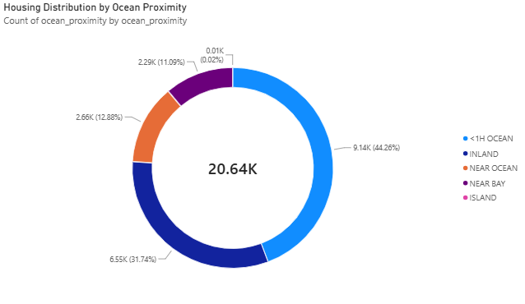

4.KPI CARD
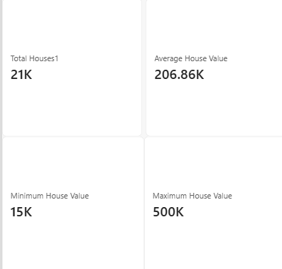

5.Line Chart
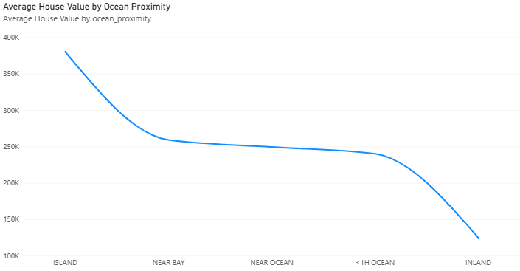

6.Clustered Column Chart
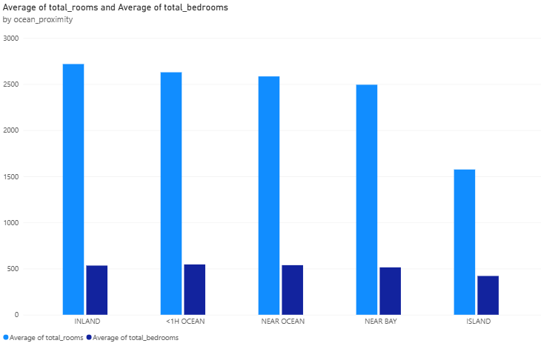

7.DASHBOARD

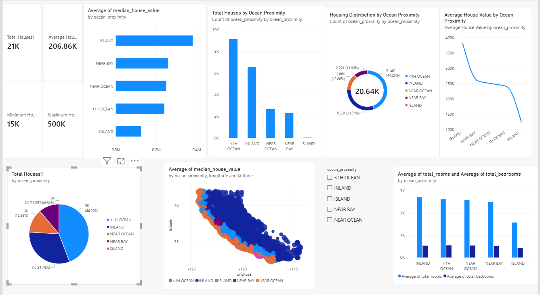

Result:

